OUR COUNTRY: SPAIN

(Gabriela)
The flag of Spain are three horizontal stripes: red, yellow and red as you can see below.

The situation of the country in relation to other Erasmus countries.
To the West; Guadalupe, to the East; Croatia and to the North; France and Belgium.

Our neighboring countries are:
Portugal

Andorra

France

Morocco
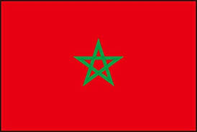

The capital city of Spain is Madrid
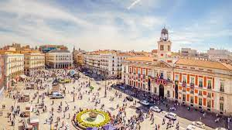

Other main cities of are:

Barcelona
Valencia
Sevilla

In Spain there are around 47.39 million people.

(M. Carme)
The organization of the country: We are a democracy with a government elected by the entire population (elections every 4 years). We are also royalty with King Philip VI.
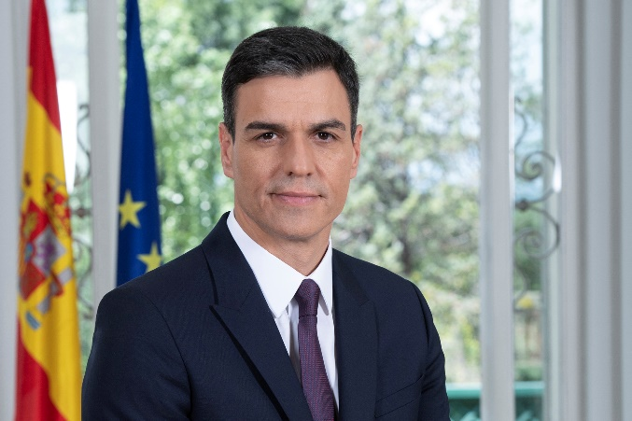
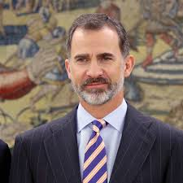

Pedro Sánchez (President) Felipe VI (King)

Languages spoken: Six official languages coexist in Spain: Spanish, Catalan, Valencian, Galician, Basque and Aranese.

The predominant religion is Catholicism.
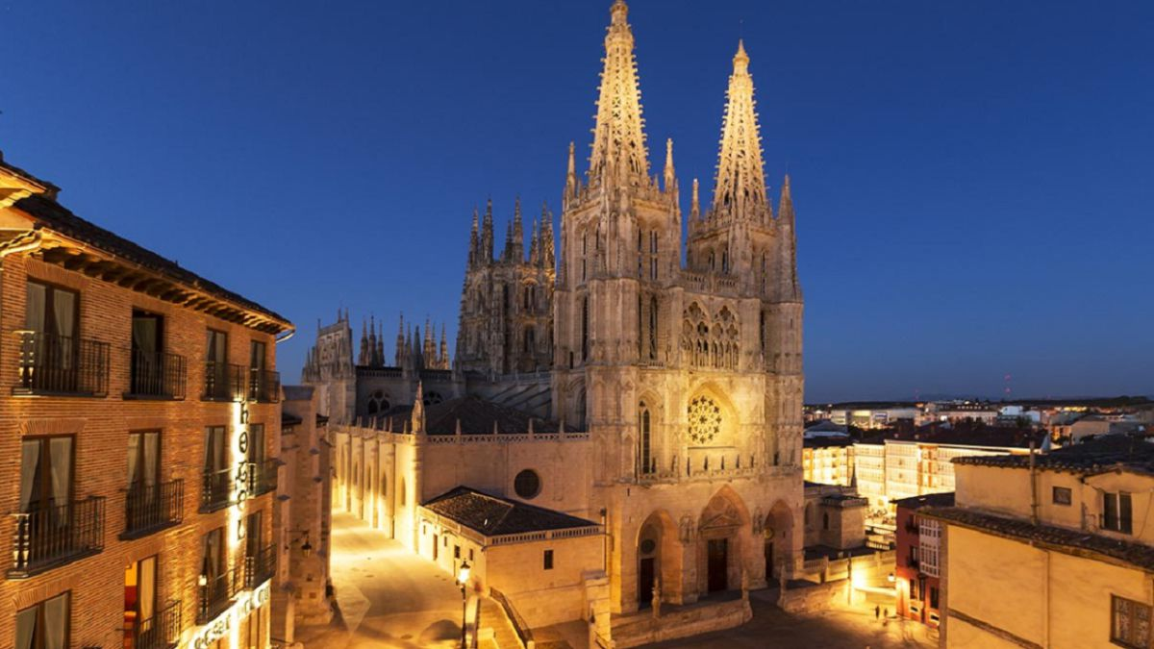

One of the most important cathedrals in Spain is Burgos’ cathedral.

A historical overview of this country.

After a civil war and after many years of dictatorship we live in a democratic state after approving a constitution in 1978.
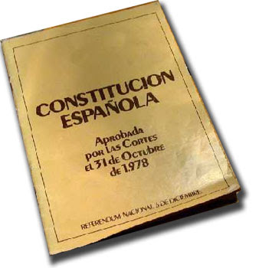

(Peter)
The climate, the relief and the adaptation of the inhabitants to these factors.

The relief of Spain is characterized by being quite high, with an average altitude of 660 meters above sea level, quite mountainous if we compare it with the rest of the European countries and only surpassed by Switzerland. The climate of Spain is Mediterranean. Its main characteristics are the numerous hours of sunshine, mild winters and summers with little rain.
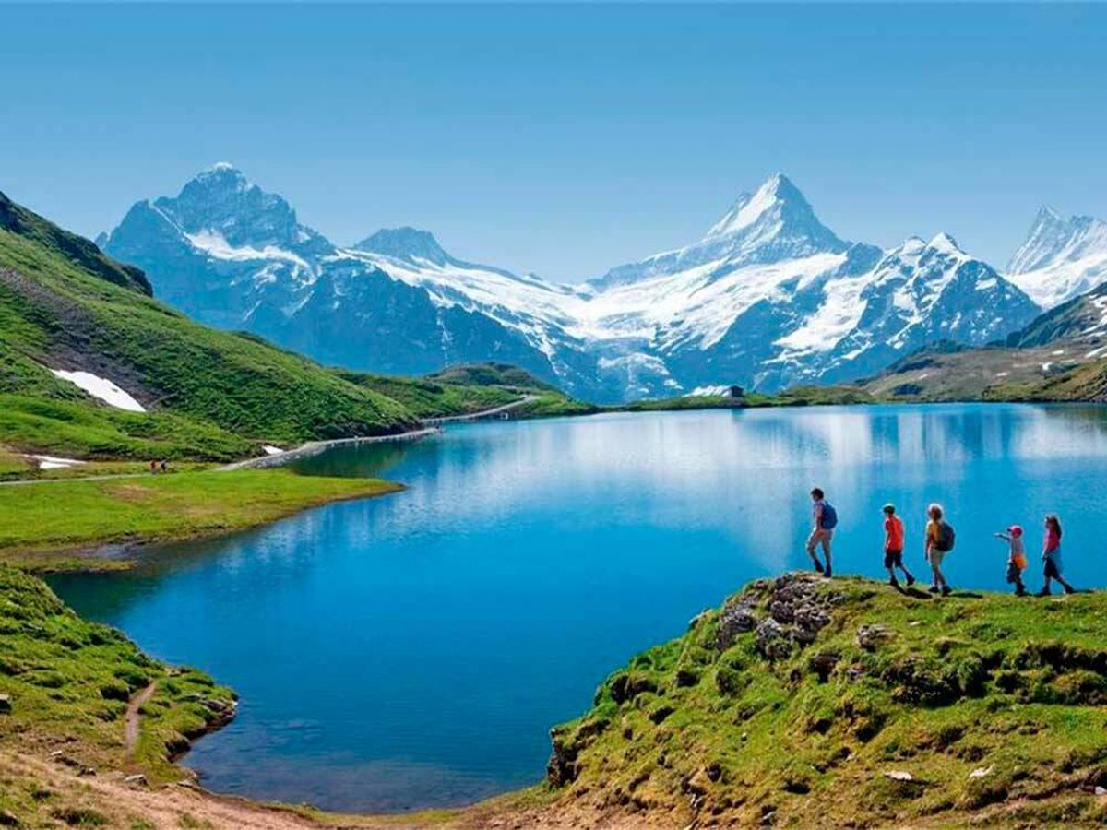

Hidrography
Eight important rivers, in terms of its route and its strong flow. Five of these rivers flow into the Atlantic Ocean, while the other three flow into the Mediterranean Sea. Tajo (1007 Km) is the longest river.

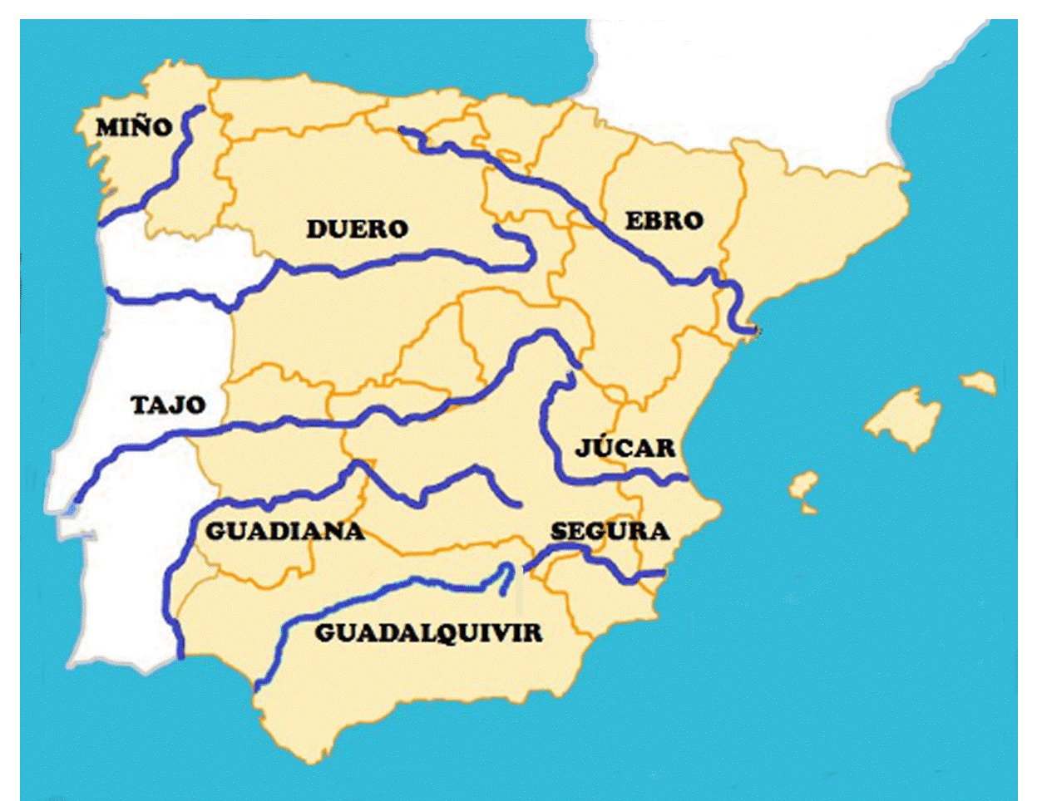

Native fauna and flora

Spain is a country with a great wealth of fauna and flora, in which the greatest biodiversity in all of Europe is found. The most representative animals are: brown bear, Iberian Lynx, wolf, Iberian imperial eagle and bearded vulture. As flora: large forests of fir and pine trees.

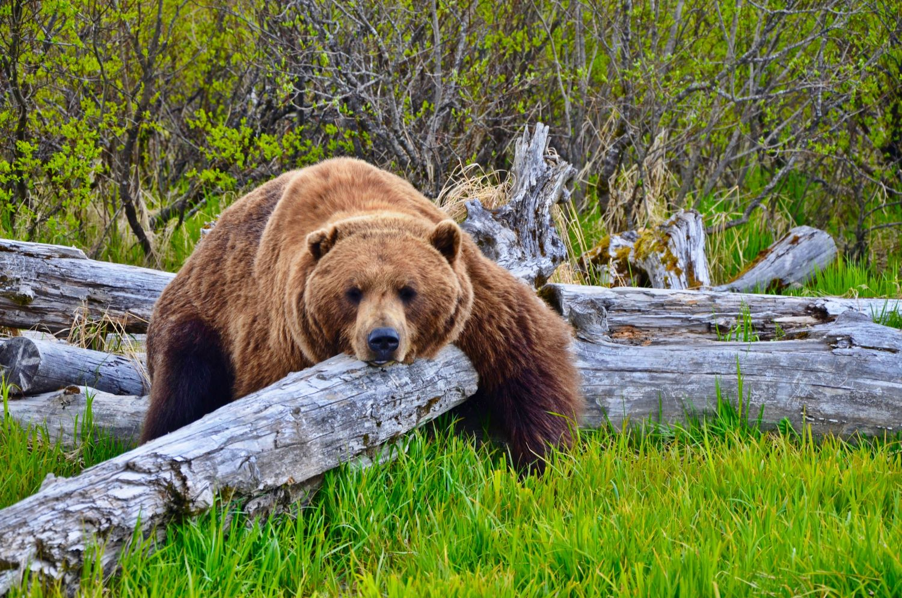
BROWN BEAR

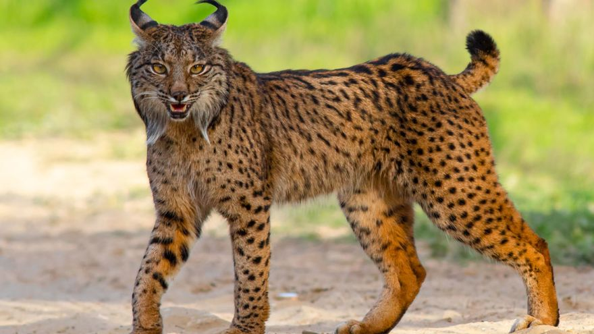
IBERIAN LYNX

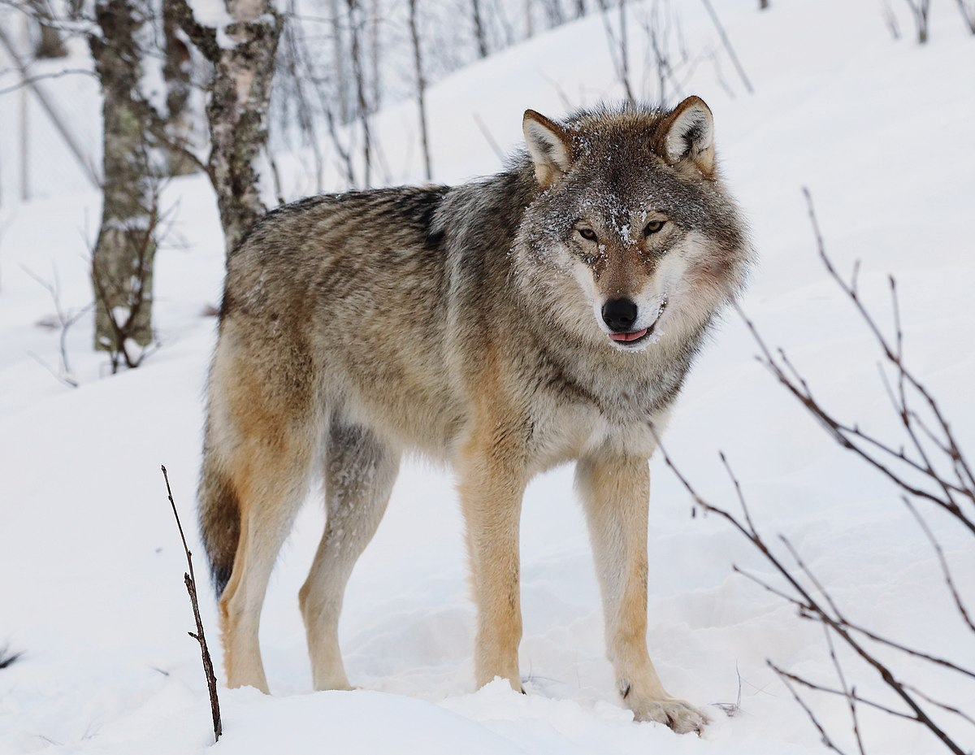
WOLF

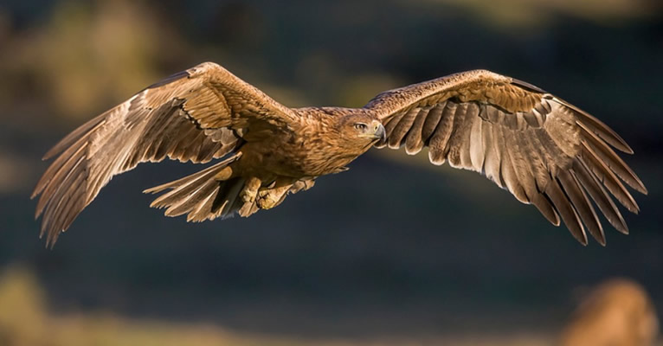
IBERIAN IMPERIAL EAGLE

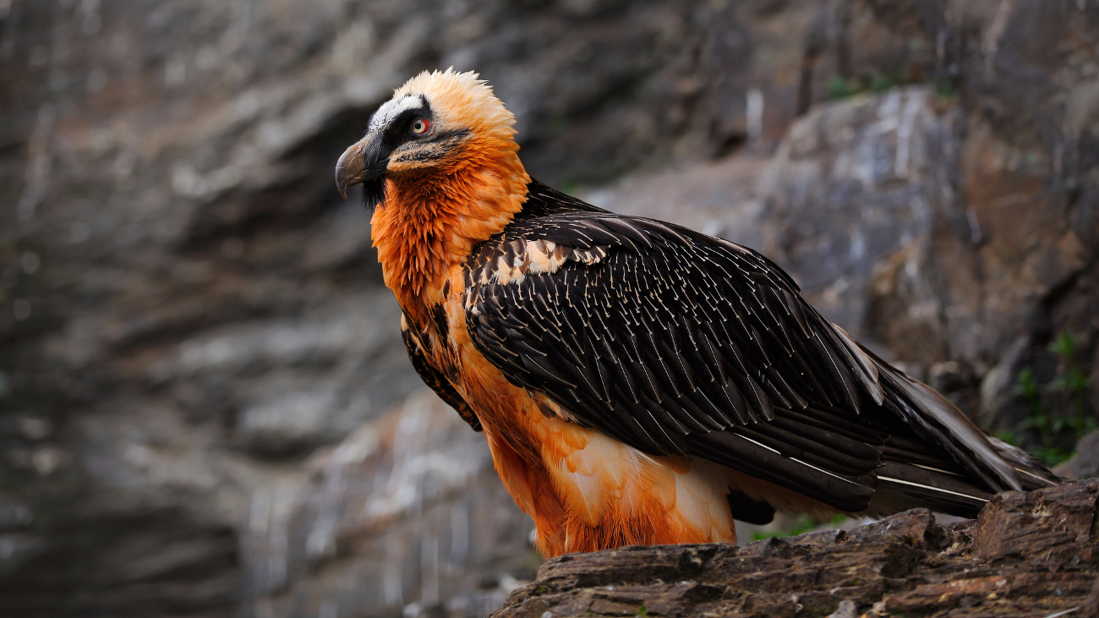
BEARDED VULTURE
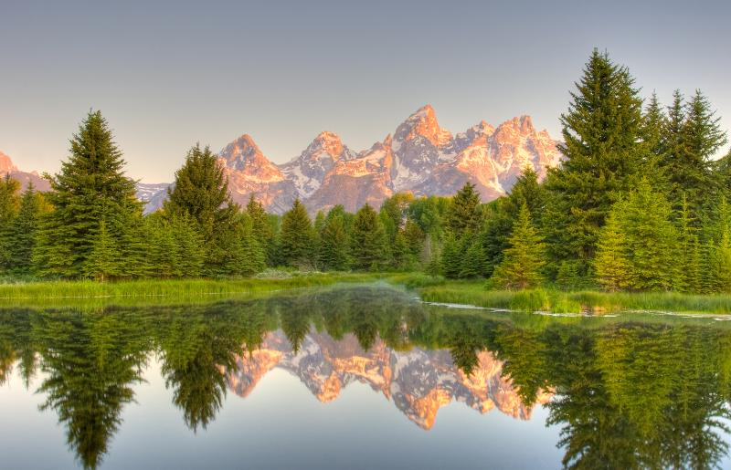

PINE TREES

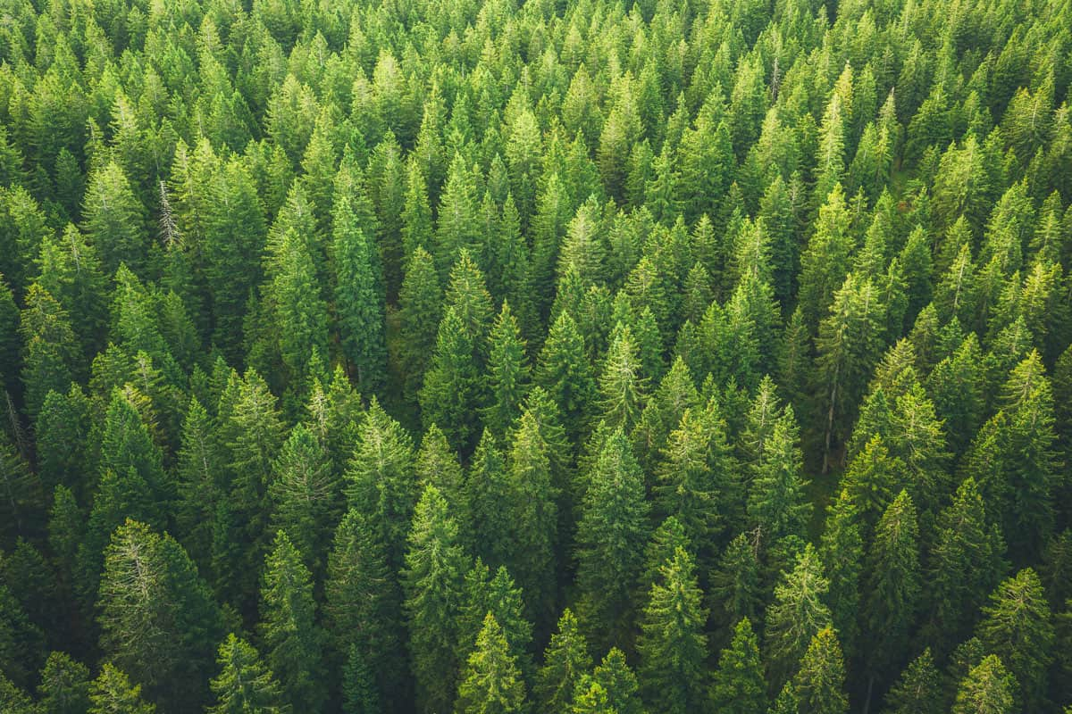

(Nagore)
ECONOMIC ACTIVITIES (agriculture, trade, industries, etc...)
The structure of the Spanish economy is based on the service sector, followed by industry, and agriculture.

-Service sector:

-Industry:
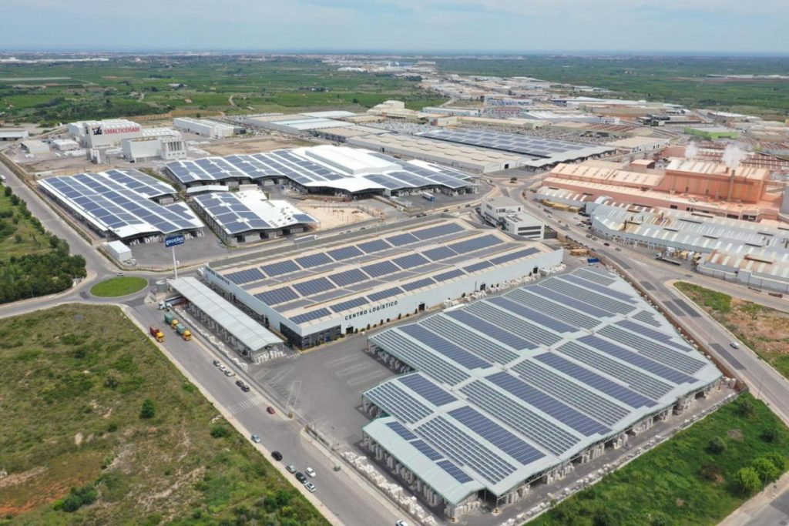

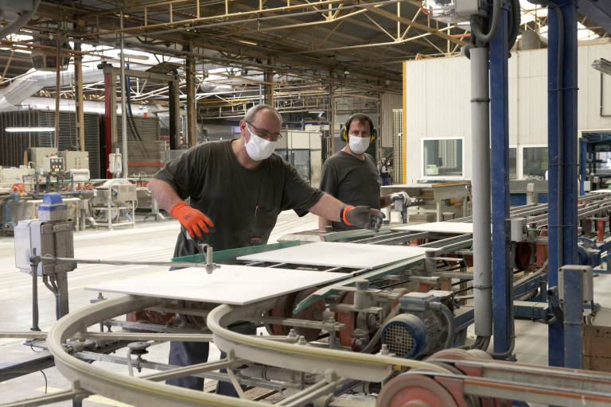

-Agriculture:

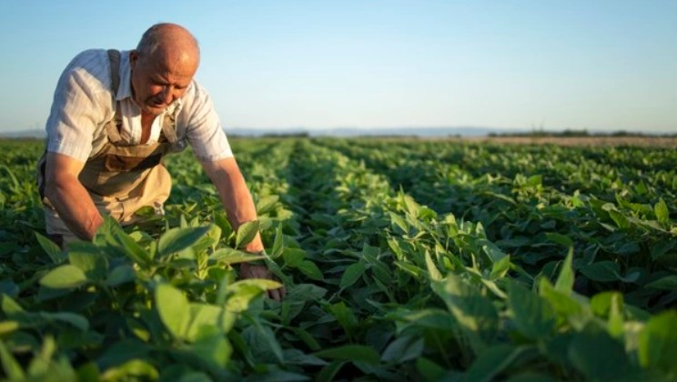
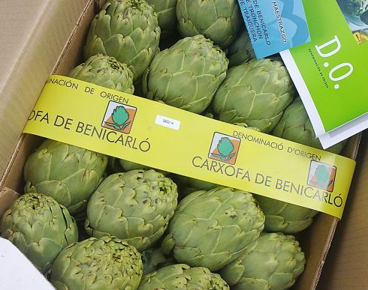

Means of communication:
Transportation in Spain is characterized by an extensive road, rail, airport and port network. The country has the longest expressway network- adding highways and motorways- in the European Union and the third in the world, only behind China and the United States.
-Bus:
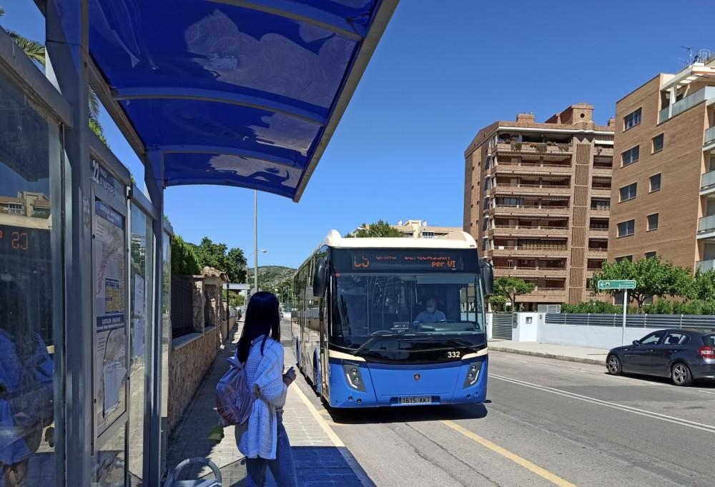

-Train:
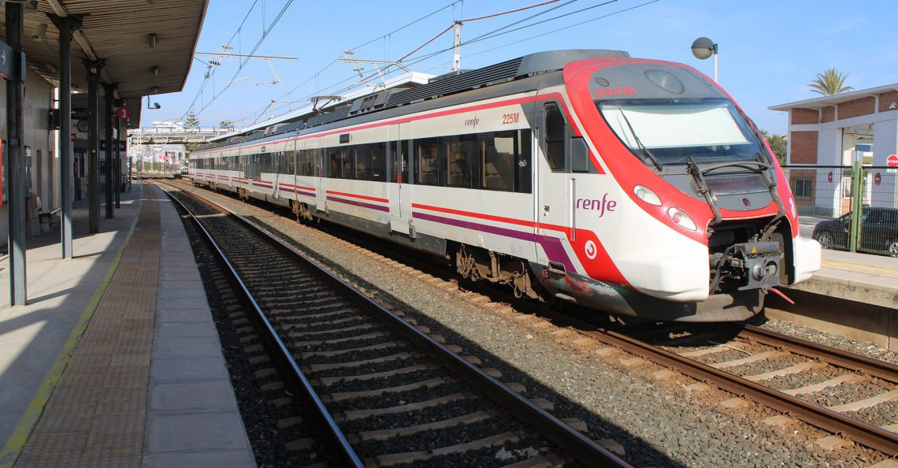
-Plane:
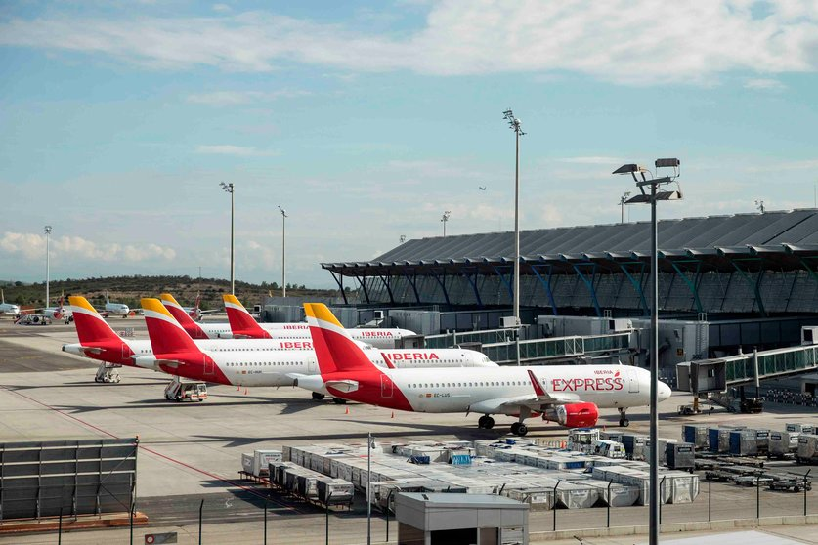

-Boat (Port network):
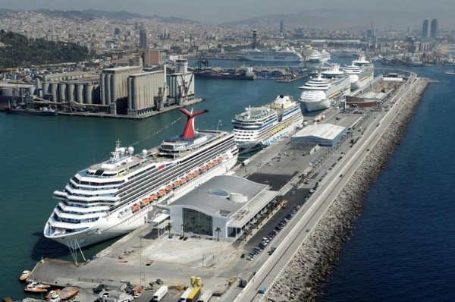

-Car (Extensive road):
